A Mini Project Report

On

TITLE OF THE PROJECT

Submitted to

IIMT COLLEGE OF ENGINEERING

(Affiliated to Dr. APJ AKTU, Lucknow)

Greater Noida



in partial fulfillment of the requirements for the award of the degree of

Bachelor of Technology

by

SHIVANI KUMARI (2202161630092)

under the guidance of
Mr Hemant Kumar
Assistant Professor

DEPARTMENT OF COMPUTER SCIENCE AND ENGINEERING

IIMT COLLEGE OF ENGINEERING

Plot No. 19 & 20, Knowledge Park-III Greater Noida, Uttar Pradesh, 2023-24

DECLARATION BY THE STUDENT

I Shivani Kumari student of B.Tech hereby declare that the project titled “MINI MALL” which is submitted by me to Department of AI&DS, IIMT College of Engineering, Greater Noida, in partial fulfilment of requirement for the award of the degree of Bachelor of Technology has not been previously formed the basis for the award of any degree, diploma or other similar title or recognition.

The author attests that permission has been obtained for the use of any copy righted material appearing in the project report other than brief excerpts requiring only proper acknowledgement in scholarly writing and all such use is acknowledged.

Shivani Kumari

Signature

Greater Noida

Date: 4/12/2024

CERTIFICATE OF ORIGINALITY

On the basis of the declaration submitted by Shivani Kumari and Pragya Singh students of B.Tech AI&DS 3rd Year. I hereby certify that the project titled “Mini Mall” which is submitted to IIMT College of Engineering, Greater Noida, in partial fulfilment of the requirement for the award of the degree of Bachelor of Technology, is an original contribution with existing knowledge and faithful record of work carried out by him/them under my guidance and supervision.

To the best of my knowledge, this work has not been submitted in part or full for any Degree or Diploma to this University or elsewhere.

Date: 4/ 12/2024 Mr Hemant Kumar
Assistant Professor
IIMT College of Engineering

ACKNOWLEDGEMENT

I would like to express my sincere gratitude to my project guide “ Mr Hemant Kumar” for giving me the opportunity to work on this topic. It would never be possible for us to take this project to this level without his innovative ideas and his relentless support and encouragement.
We are very thankful to respected Associate Lecturer Mr Hemant Kumar for helping and encouraging us in every aspect of my academic study. Also, we would like to thank all the respondents who filled the questionnaire and helped us with the continuation of the project. Finally, we would like to thank all of our friends for uplifting our spirit to complete the report in time.

CONSENT FORM

This is to certify that We Shivani Kumari and Pragya Singh student of B.Tech. (AI&DS) presently in the Vth Semester at IIMT College of Engineering, Greater Noida give our consent to include all my personal details (Shivani Kumari -2202161630092) and
( Pragya Singh -2202161630070) for all accreditation purposes.

Place: IIMT COLLEGE OF ENGINEERING
Shivani Kumari
Date: 6/02/2024

DECLARATION FORM

We are the students of Vth sem B.Tech CSE (AI&DS) hereby declare that utmost care was take not to harm anyone either physically or emotionally. I have gone through project guidelines including plagiarism.

Shivani Kumari
(2202161630092)

Date:4/12/2024

Place: IIMT COLLEGE OF ENGINEERING

LIST OF FIGURE

Figure No. |  | Figure Name | Page No.
1.1 |  | Project Frame Work | 3
2.1 |  | Use Case Diagram | 9
2.2 |  | Activity Diagram | 10

LIST OF ABBREVIATION

BIM Bachelor of Information Management

CRUD Create Read Update and Delete

CSS Cascading Style Sheet

ERD Entity Relationship Diagram

HTML Hypertext Markup Language

HTTP Hypertext Transfer Protocol

IT Information Technology

MIS Management Information System

TU Tribhuvan University

UML Unified Modeling Language

XAMPP Apache Http Server MySQL Database PHP and Perl

TABLE OF CONTENTS

ACKNOWLEDGEMENT

CONSENT FORM

DECLARATION FORM

LIST OF FIGURES

LIST OF TABLES

LIST OF ABBREVIATION

CHAPTER 1
1. INTRODUCTION ................................................................................................... 1

  - Efficiency and time saving...................................................................................1

  - Accuracy and Error Reduction........................................................................... 1

  - Custamization and flexibility .............................................................................1

  - Inventory Management ...................................................................................1

  - Enhanced Customer Experience .........................................................................1

  - Data Analysis and Reporting ..............................................................................2

  - Compliance and Record-Keeping .......................................................................2

  - Scalability ............................................................................................................2

  - Methodology .........................................................................................................2

CHAPTER 2

2.1 Literature Review ...........................................................................................................5

2.2 Analysis of Task and Activities .................................................................................... 5

2.3 Problems Analysis ......................................................................................................... 5

2.4 Analysis of Possible Solutions .......................................................................................5

2.5 Feasibility Analysis ....................................................................................................... 6

2.5.1 Technical Feasibility ...........................................................................................6

2.5.2 Economic Feasibility ...........................................................................................6

2.5.3 Operational Feasibility ..................................................................................... .

2.6 Requirement Analysis ...................................................................................................7

2.6.1 Functional Requirement .......................................................................................7

2.6.1.1 Use-Case Diagram .....................................................................................8

2.6.2 Non-Functional Requirement ...............................................................................9

2.7 System Design ..............................................................................................................10

2.7.1 Process Flowchart .............................................................................................10

2.8 System Implement
2.8.1 Tools used .........................................................................................................11

CHAPTER 3
Existing Methology ....................................................................................... 12

CHAPTER 4
Proposed Methology ....................................................................................... 13

CHAPTER 5
Result Analysis .......................................................................................14

CHAPTER 6
Conclusion & Future Work .......................................................................................15

REFRENCES

CHAPTER 1

INTRODUCTION

Welcome to our mini project, where we harnessed the power of Python to develop a seamless app for automatic bill generation. Say goodbye to manual calculations! With just a few clicks to select your desired items, our application will effortlessly generate and print a detailed bill, simplifying your shopping experience.

In this venture, we harnessed the power of Python to craft a user-friendly app designed to streamline the shopping experience. Imagine a world where selecting your desired items triggers an automatic bill generation – that's precisely what our Python-based application achieves.

Automated billing systems are crucial in various industries and businesses for several reasons. Implementing a mini project that generates bills automatically when selecting items and their quantities offers numerous advantages:

1.1 Efficiency and Time-Saving:
Automating the billing process significantly reduces the time required to generate invoices. Manually calculating and creating bills can be time-consuming and prone to errors. With an automated system, the entire process is streamlined, leading to increased efficiency and productivity.

1.2 Accuracy and Error Reduction:
Human errors in calculations, transcription, or data entry can result in inaccuracies in billing. An automated system eliminates such errors, ensuring that the generated bills are accurate. This not only saves time but also enhances the overall reliability of the billing process.

1.3 Customization and Flexibility:
A well-designed mini project can allow users to customize bills according to specific requirements. Users can select items, input quantities, and even apply discounts or promotions. This flexibility caters to the diverse needs of businesses and enhances the adaptability of the billing system.

1.4 Inventory Management:
Integrating an automated billing system with inventory management allows for real-time tracking of stock levels. As items are selected and quantities adjusted during billing, the system can update the inventory, providing a more accurate picture of stock availability. This helps in preventing overstock or stockouts.

1.5Enhanced Customer Experience:
Automatic bill generation contributes to a smoother and faster checkout experience for customers. Quick and accurate billing processes leave a positive impression on customers, leading to increased satisfaction and potentially repeat business.

1.6Data Analysis and Reporting:
Automated billing systems often come with reporting features that provide valuable insights into sales trends, popular products, and revenue streams. Analyzing this data can inform strategic business decisions, helping organizations optimize their offerings and pricing strategies.

1.7 Compliance and Record-Keeping:
Automated billing systems can assist in maintaining compliance with tax regulations and other financial standards. They also facilitate proper record-keeping, ensuring that all transactions are documented accurately, which is essential for audits and financial reporting.

1.8 Scalability:
As businesses grow, the demand for efficient billing processes increases. An automated billing system can easily scale to handle a higher volume of transactions without a proportional increase in manual effort, making it suitable for businesses of varying sizes.

Imaginative Description for the User

Welcome to the world of seamless financial management with our revolutionary Automatic Bill Generator software! Picture a future where creating and managing bills is not just a task but a breeze, where tedious paperwork and manual calculations become relics of the past. Our software brings to life the vision of an effortless, efficient, and error-free billing process. Say goodbye to the hassle of crunching numbers and hello to a futuristic experience where the Automatic Bill Generator becomes your virtual assistant, streamlining your billing procedures and freeing up your time for what truly matters. Embrace the ease of automation, and let your billing tasks transform into a smooth, innovative journey with our cutting-edge software.

1.9 Methodology :

A methodology is a model for the design, planning, implementation, and achievement of the
project objective. In order to gather the information and data, and to discover the design of the application various methods has been applied.

• Project Planning

In this phase the process involved in the overall development of the system and the activities that must be performed as well as the strategies were defined. Various planning activities has been be conducted, which includes the planning of work, schedule, budget, gathering resources, and etc. Those proper planning activities helps me to complete the project on time and within the budget.

• Project Execution

In the third phase, the requirement documented were prioritized and the system view was developed. Different types of feasibility were analyzed for the completion of the project with in the estimated time, budget and the resources required. The overall module of the system was developed in this phase. The actual implementation was performed and the testing of the system was also executed. This phase was the longest phase.

• Project Closure

This is the last phase, in which the project is completed and formally closed. In this phase the overall process and the achievement is documented and presented to the mentor. Project Closure involves handing over the actual implementation view of the project along with the documentation including all the activities involve in project from scratch level to the completion of the project to the concerned External and Internal supervisor.

CHAPTER 2

LITERATURE SURVEY

2.1 Literature Review

For the purpose of this project and its required features, other existing systems were referred to, so as to gain inspiration and observe what features the software made for the general use have and might be need for this project. When researching for existing software that might help in the process of building this project.
“Mini Mall Design Based on Internet Environment”. This paper deals with the design of Internet billing system, in which it is possible pay invoices electronically. This approach is implemented via virtual banks, in which the process of money transfer can be implemented.

“Mini Mall Documentation”. This Mini Mall software system is the most sophisticated web based. This web based software has been designed especially for small & midsized businesses. This Mini Mall is the most reliable, flexible and scalable website that helps streamline billing while considerably reducing operating costs.

2.2 Analysis of tasks and activities

Analysis is a process of gathering and interpreting facts, diagnosing problems and the information to recommend improvement on the system. It is a problem solving activity that requires intensive communication between the system users and system developers. System analysis or study is an important phase of system development process. Many task and activities had been performed which helped to fulfill the main objective of our project. Major objective of the project was to get the information about the use of technology in one of the organization in the country.

2.3 Analysis of Problem

The organization is facing certain problems. The main problem of this organization is implementation of manual process, in these time organization uses pen and copy for keeping the record use the paper bill for billing during selling product. Similarly, the process and implementation is major issue. Implementing required changes to organizational culture which is a major challenge.

2.4 Analysis of possible solutions

Stores should improve their technology. They must adopt the new strategy of billing system. They must invest in new technology that will put them ahead of the rest of the shop. They should therefore implement a web-based billing and shopping system.

2.5 Feasibility Analysis

Feasibility study is made to see if the project on completion will serve the purpose of the organization for the amount of work, effort and the time that spend on it. Feasibility study lets
the developers for see the future of the project and usefulness. A feasibility study of a system proposal is according to its workability, which is the impact on the organization ability to meet the user needs and effective uses of resources. The document provides the feasibility of the project that is being designed and list various areas that were considered very carefully during the feasibility study of this project such as Technical, Economic and Operational feasibilities.

2.5.1 Technical Feasibility

The current system developed is technically feasible. It is a web based user interface. Thus it provides an easy access to the users. The database’s purpose is to create, establish and maintain a workflow among various entities in order to facilitate all concerned users in their various capacities or roles. Permission to the users would be granted based on the roles specified. Therefore, it provides the technical guarantee of accuracy, reliability and security.

2.5.2 Economic Feasibility

A system can be developed technically and that will be used if needed must still be a good investment for the organization. In the economic feasibility, the development cost in creating the system is evaluated against the ultimate benefit derived from the new systems. Financial benefits must equal or exceed the costs. The system is economically feasible. Since the interface for this system is developed using the existing resources available at the organization, there is nominal expenditure and economic feasibility for certain.

2.5.3 Operational Feasibility

Proposed projects are beneficial only if they can be turned out into information system. That will meet the organization’s operating requirements. Operational feasibility aspects of the project are to be taken as an important part of the project implementation. Some of the important issues raised are to test the operational feasibility of a project includes the following:

• Is there sufficient support for the management from the users?

• Will the system be used and work properly if it is being developed and implemented?

• Will there be any resistance from the user that will undetermined the possible application benefits?

2.6 Requirement Analysis
It is the process of gathering the information about the required and existing systems and distilling the user and system requirements from this information. It involves Functional Requirement and Non-Functional Requirement.

2.6.1 Functional Requirements

• Admin can able to perform CRUD operations.

• Admin can review the sales.

• Cashier provide the accurate bill.

• Customers can able to receive the bill in digitize form.

2.6.1.1 Use Case Diagram

A use case diagram is a graphic depiction defined by the unified modeling language (UML) whose aim is to show the interactions among the elements of a system (actors), their goals (represent as use case) and any dependencies between those use cases. It is used to identify the primary elements (actors) and processes (use cases) that form the system. The use case diagram describes different activities performed by different actor within the system. It represents system functionality from users’ perspective. Use case diagram describes a sequence of actions that provides a measurable value to an actor and is drawn as horizontal ellipses. Fig:2.1: Use case Diagram of Billing Management System

• System is portable and we can switch the server very easily.

• The system should support almost in all browser.

2.7 System Design

Systems design is the process of defining the architecture, product design, modules, interfaces, and data for a system to satisfy specified requirements. Systems design could be seen as the application of systems theory to product development. This part of the project consists of all the work performed from the very initial sketching of the outcome of the project to successful designing of the project.

2.7.1 Process Flowchart

A flowchart is a type of diagram that represents a workflow or process. A flowchart can also be defined as a diagrammatic representation of an algorithm, a step-by-step approach to solving a task. The flowchart shows the steps as boxes of various kinds, and their order by connecting the boxes with arrows Flow chart is a modeling technique that traces a movement of data in a computer system and show how the data is to be processed. It is a type of diagram that represents an algorithm, workflow or process, showing the steps as boxes of various kinds, and their order by connecting them

2.8 System Implementation

This part will look at the implementation of the system including the database and the main application. The database was created first followed by the main application which was integrated with the database. This section highlights the main features of the system and how they were implemented.

2.8.1 Tools used

During this development of report different tools were used. Mainly used tools are as follows:

• HTML: It is basically used to format text as titles and headings, to arrange graphics on this system and also used to link different pages within a system.

• CSS: In this system CSS is used for development sites structure by creating design or outline the html element and describing the presentation to different pages, including colors, layout and fonts.

• Bootstrap: In this project, Bootstrap is used for designing and making the website screen responsive. Different components and models are used for attractive user interface. In this project Bootstrap version 4.0.0 is used.

• PHP: PHP code is embedded into HTML for making website dynamic and used for connecting website to database. In this system PHP version 7.3.11 is used.

• MySQL: In this project, MySQL is used for the database management of the system. Different data is stored in the server to make the website dynamic.

• XAMPP: It is used for creating and configuring with database which is written in MySQL without internet. In this project XAMPP version 3.2.4 is used.
• Microsoft Office: The Microsoft office word document is used for softcopy documentation of the project. All the document design and numeration are done by using Microsoft Office Word 2019.

• JavaScript: In this project JavaScript is used for creating some animation in page content.

• Web Browser: Google Chrome browser is used to the run the localhost system of a project.

• Sublime Text: Sublime Text version 3.2 is used to write down all the HTML, CSS and PHP code in this project.

CHAPTER 3

EXISTING METHODOLOGY

- Inability of modification of data:
The managing of huge data effectively and efficiently for efficient results, storing the details of the consumers etc. in such a way that the database can be modified as not possible in the current system.

2. Not user friendly:
The existing system is not user friendly because the retrieval and storing of data is slow and data is not maintained efficiently.

3 .Difficulty in reports generating:
Either no reports generating in a current system or they are generated with great difficulty reports take time to generate in the current system.

4. Manual operator control:
Manual operator control is there and lead to a lot of chaos and errors

5. Lot of paperwork:
Existing system requires lot of paper work and even a small transaction require many papers fill. Moreover any unnatural cause (such as fire in the organization) can destroy all data of the organization. Loss of even a single paper led to difficult situation because all the papers are interrelated.

6. Inability of sharing the data:
Data cannot be shared in the existing system. This means that no two persons can use the same data in existing system. Also the two departments in an organization cannot interact with each other without the actual movement of data.

7. No support in decision-making:
Existing system does not support managerial decision-making.

8. No support in strategic competitive advantage:
Existing system do not support strategic competitive advantage.

CHAPTER 4

PROPOSED METHODOLOGY

1 . Easiness in modification of data:
The proposed system provides managing of huge data effectively and efficiently for efficient results, storing the details of the customers, employees etc. in such a way that the database can be modified.

2. User friendly:
The proposed system is user friendly because the retrieval and storing of data is fast and data is maintained efficiently. Moreover the graphical user interface is provided in the proposed system, which provides user to deal with the system very easily.

3. Reports are easily generated:
Reports can be easily generated in a proposed system. So any type of reports can be generated in a proposed system, which helps the managers in a decisions-making activity.

4. Sharing the data is possible:
Data can be shared in proposed system. This means that two or more persons can use the same data in existing system provided that they have right to access that data. Also the two or more departments in an organization can easily interact with each other without the actual movement of data.

5. No or very few paperwork:
The proposed system either does not require paper work or very few paper works is required. All the data is feted into the computer immediately and various bills and reports can be generated through computers. Since all the data is kept in a database no data of the organization can be destroyed. Moreover work becomes very easy because there is no need to keep data on papers.

6. Support strategic competitive advantage:
Proposed system supports strategic competitive advantages. Since the proposed systems provide easiness in reports generating it will provide strategic advantages among competitors.

7. Computer operator control: Computer operator control will be there no errors. Moreover storing and retrieving of information is easy. So work can be done speedily and in time.

CHAPTER 5

RESULT ANALYSIS

To analyze the results of a project mini mall, assess key performance indicators (KPIs) like construction timelines, budget adherence, and adherence to the planned design. Evaluate the leasing and occupancy rates, sales data from tenants, and overall customer satisfaction. Consider factors like marketing effectiveness, operational efficiency, and any unforeseen challenges faced during the project. This analysis will provide a comprehensive understanding of the project's success and areas for enhancement.

DISCUSSION:

The development focused primarily on the usability of such an application and the functionality needs of the user. The application that was created successfully met the usability and functional requirements of the user and gained their acceptance.

FINDING:

The major findings after the completion of the project are as follows:

• The project helps in gaining the practical knowledge for implementing the theoretical concept that has been learned.

• After analyzing about the organization, it is known that if organization uses the same traditional approaches to billing and keep data then it would increase the cost of product.

• If the organization uses the application for billing and keeping record then thus, the organization would be able to meet its goal comfortably.

CHAPTER 6

CONCLUSION & FUTURE ENHANCEMENT

CONCLUSION:

In this system, the recording of bill is done manually. The previous system was time consuming, less secured and took effort and physical space to keep track of paper documents. To solve this problem Billing system is designed. It records data and information in a systematic way and also contains log-in system in which authentication is needed to use the system that makes system secure. As the system records the data digitally it won’t take effort and physical space to keep track of paper document.

FUTURE ENHANCEMENT:

With the existing constraints, the developed system is not what was planned initially. The primary aim of this project has been met. All the objectives that were set out have been completed and giving positive results in the end. In future some features that can be added for better performance are as below:

- Attractive user interface can be designed.

2. Others Iterative module can be added

REFERENCES

Billing system design based on internet environment. (n.d.). Retrieved from https://www.researchgate.net/publication/242071321_Billing_System_Design_Based
on_Internet_Environment
Billing system short documentation. (n.d.). Retrieved from https://www.scribd.com/document/348664641/billing-system-shortdocumentation KetanRajpal(ketanrajpal14). (n.d.). Retrieved from https://www.scribd.com/user/358260425/Ketan-Rajpal Muzhir AL-ANI | Professor | Doctor of philosophy in engineering. (

SNAPSHOTS OF FORMS

Main Form:

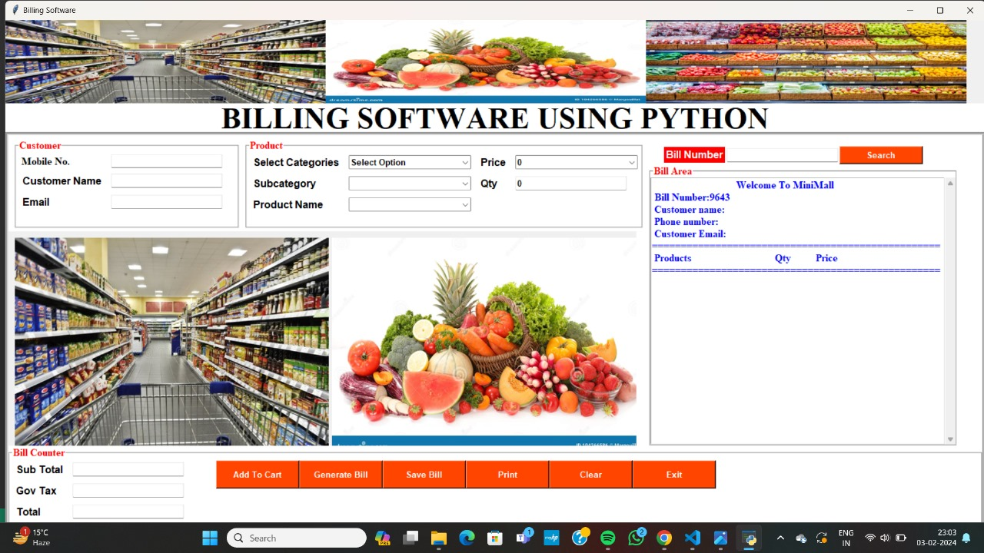

Customer Details:

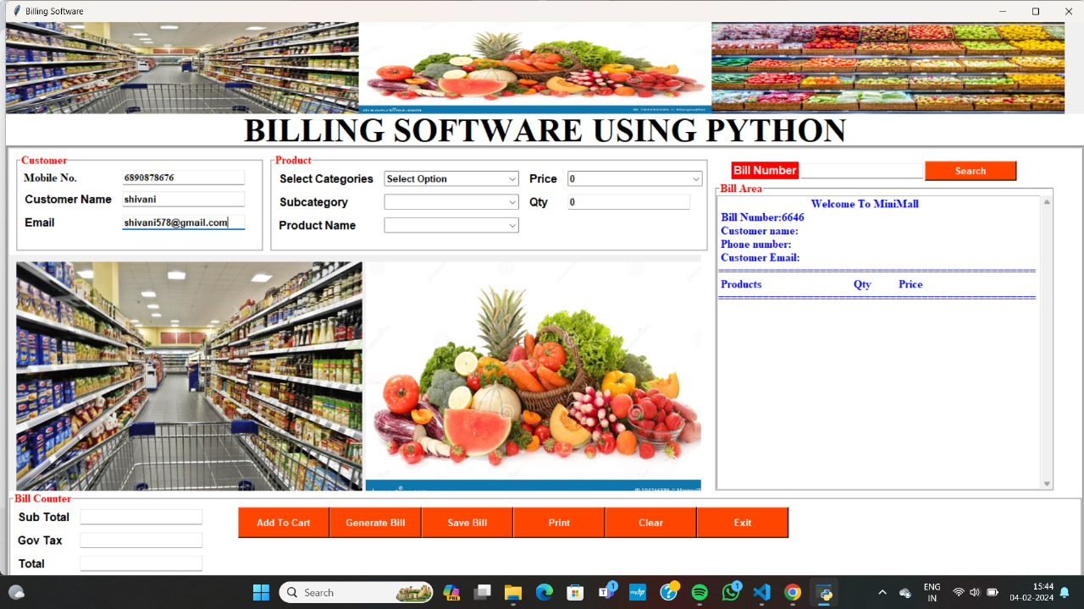

Order Products

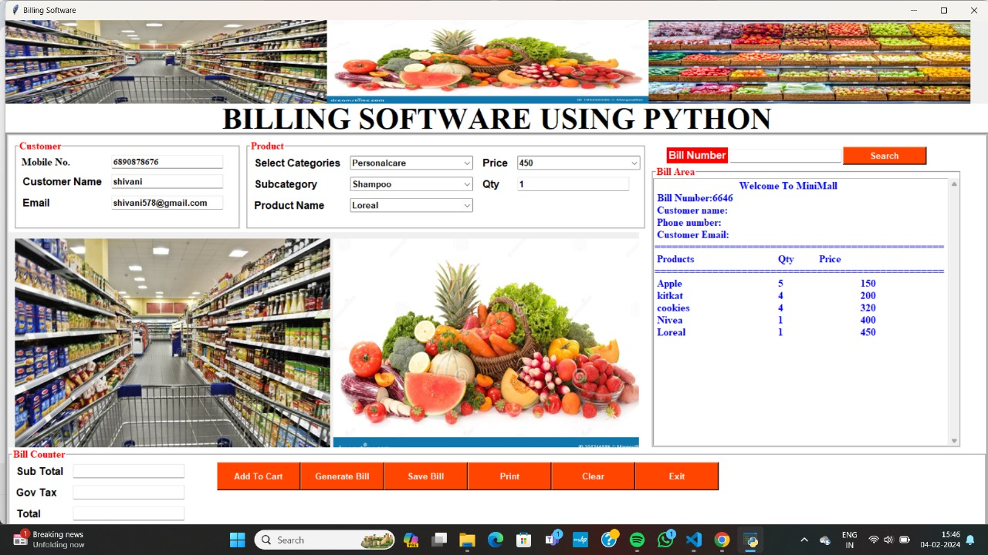

Add to Cart

Bill Generated:

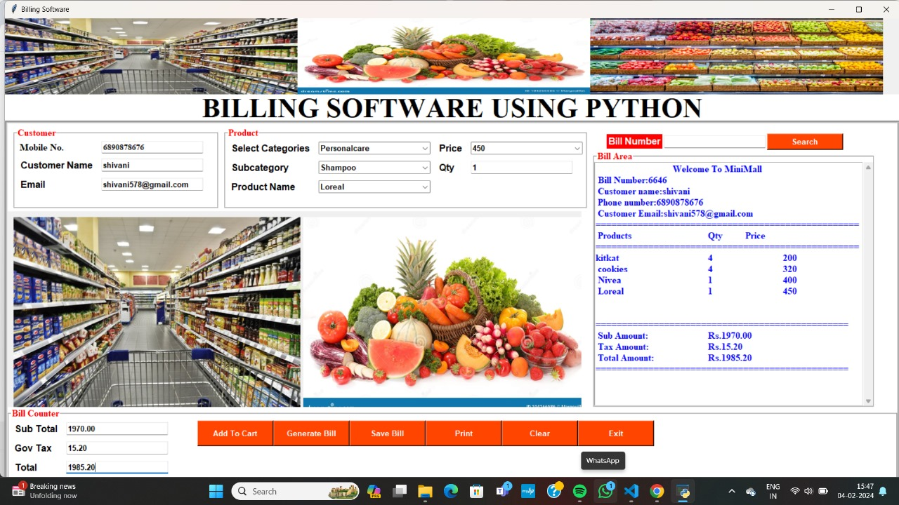

Bill Saved

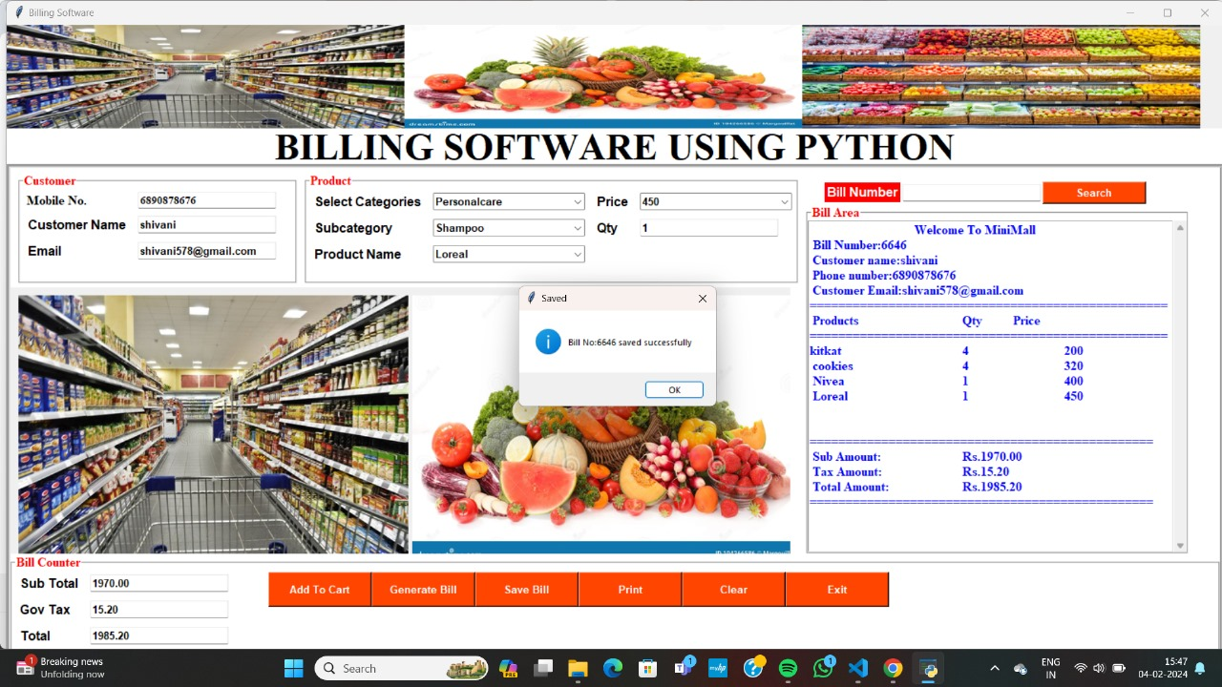

Bill Printed

